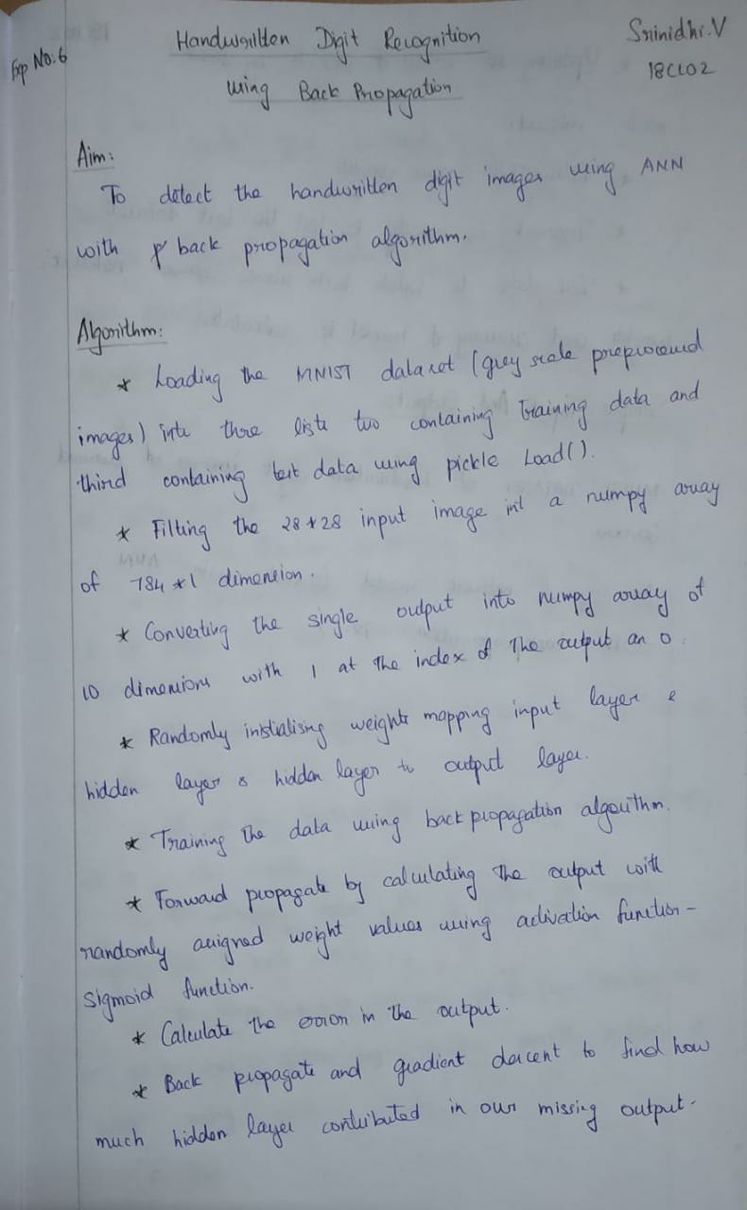



**Program:**

Digit_reg.py:

import numpy as np import mnist_loader as ml import Network as net import testi as tt import bar as br np.random.seed(1)

weights = 2*np.random.random((784,50)) - 1 weights1 = 2*np.random.random((50,10)) - 1

tr_data, val_data, test_data = ml.load_data()

tr_inputs = [np.reshape(x, (784, 1)) for x in tr_data[0]]

tr_outputs = [ml.vectorized_result(x) for x in tr_data[1]]

for i in range(50000):

weights , weights1 = net.train(tr_inputs[i],tr_outputs[i],weights,weights1) if(i % 500) == 0 :

br.progress(i, 50000)

br.progress(50000, 50000, cond = True)

print ("\n") print ("Network Trained and ready to be operated")

te_inputs = [np.reshape(x, (784,1)) for x in test_data[0]] te_outputs = test_data[1] tt.check(te_inputs,te_outputs,weights,weights1)

mnist_loader.py:

import pickle import gzip import numpy as np

def load_data(): f = gzip.open('mnist.pkl.gz', 'rb') training_data, validation_data, test_data = pickle.load(f, encoding = 'latin1') f.close() return (training_data, validation_data, test_data)

def vectorized_result(j): e = np.zeros((10, 1)) e[j] = 1.0 return e

Network.py:

import numpy as np

def sigmoid(x): return 1/(1+np.exp(-x))

def deriv_sigmoid(x): return x*(1-x) def train(inputs,output,weights,weights1):

x = inputs.T y = output.T

l1 = sigmoid(np.dot(x,weights)) l2 = sigmoid(np.dot(l1,weights1))

error = y - l2

l2_del = error * deriv_sigmoid(l2)

error0 = l2_del.dot(weights1.T)

l1_del = error0 * deriv_sigmoid(l1)

weights1 += np.dot(l1.T,l2_del) weights += np.dot(x.T,l1_del) return weights,weights1

bar.py:

import sys

def progress(count, total, cond=False):

bar_len = 60 filled_len = int(round(bar_len * count / float(total)))

percents = round(100.0 * count / float(total), 1) bar = '|' * filled_len + '-' * (bar_len - filled_len)

if cond == False: sys.stdout.write('[%s] %s%s\r' % (bar, percents, '%')) sys.stdout.flush()

else: sys.stdout.write('[%s] %s%s' % (bar, percents, '%'))

testi.py:

import Network as net import numpy as np

def feedforward(x,weights,weights1):

l = x.T l1 = net.sigmoid(np.dot(l,weights)) l2 = net.sigmoid(np.dot(l1,weights1)) return l2; def check(te_inputs,te_outputs,weights,weights1):

correct = 0

for i in range(len(te_inputs)):

out = feedforward(te_inputs[i],weights,weights1) f_out = np.argmax(out) if(f_out == te_outputs[i]): correct += 1 print ("Accuracy Of the Network is " , ((correct/10000)*100))

**Output:**

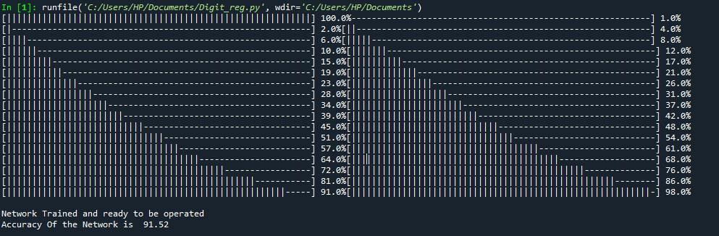

**Result:**

Thus using MNIST dataset handwritten digit recognition is implemented using ANN with backpropagation algorithm.